**COMP 2215 Final Project**

**General Election Survey Application**

The aim of this Project is to design and build an application for collecting survey for the incoming election in the Republic of Turkey. In this application, only one city is included in the survey: Izmir. There are 12 parties to be included in your application that are qualified for the incoming election:

(A – Party A, B – Party B, C – Party C, ….. , L- Party L)

In the general elections, Izmir have 28 seats in the parliament. Therefore, each of these parties will have 28 nominees for the seats who are being voted in the election that you should provide. For this process, you may use the names from the previous elections or you may randomly create 28 candidates for each party that will compete for the seats.

The project has two parts: In the first part you need to create a user interface for this survey application and in the second part you need to store this information in persistent data storage file or a database.

**PART 1: Survey User Interface**

You are given the sketch of the required user interface. You need to choose appropriate Swing components or web page components to implement the GUI. Pay attention to the following process logic in the sketch:

**1-** In the first window, provide two options, one for seeing the results of this survey application and two for participating in this study.

**2-** If the user decides to see the statistics, then first you need to show the overall results for each party. This user interface (UI) should also give the user option to choose a specific part to see the results for the candidates of the chosen party.

**3-** Depending on the party selected, window 2 then displays the statistics of the candidates of this party. Make sure that you list all of the 28 candidates for each party.

**4-** If the user decides to participate in this survey, then first we need to collect some demographics information about that participant. For example; their age, gender, profession and education. Regarding the gender; they can only choose male or female. For education; there will be 4 options: primary school, high school, university and post-graduate.

**5-** When the user completes entering demographic information, then ask them which party they will vote for. You have to show all of the parties as options that are listed up in this document.

**6-** When the user chooses a specific party, then list all the candidates for that party. The user has to vote for 14 candidates, but when the user votes, all the 28 candidates of the same party also get one extra vote.

**7-** If the user does not want to vote for a specific party, then show all the candidates registered in the application. The user has to vote for 28 candidates.

**8-** In the statistical analysis, each candidate and party start with 0 votes. For each participant in the survey, the values are updated according to the participant’s choices. Then, the percentage of the parties and candidates are calculated according to the votes that they get. (ex: if 100 people participates and if party A gets 35 votes, then the percentage of party A is %35. For candidates, a similar calculation is done. For 100 participants, 100x28 candidates will be updated. Then, a similar percentage is taken for a specific candidate).

The sample interface design can be done accordingly with the following images. For any changes that you want to do on the interface, it will be ok. However, the functionality of the app should not change and work in parallel with the provided sketch.

**Statistics Windows:**

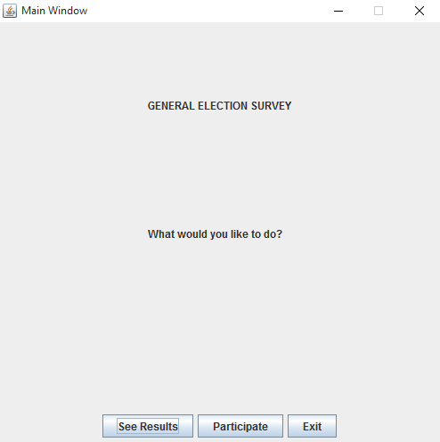

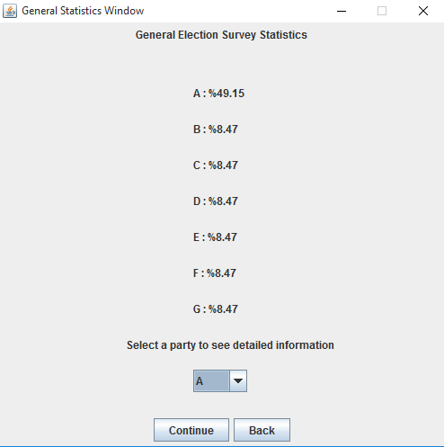

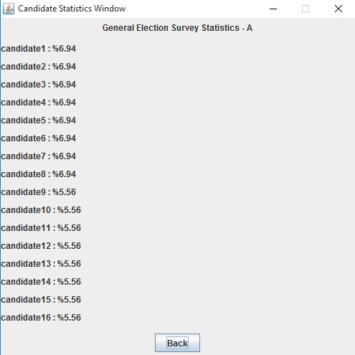

**Participation Windows:**

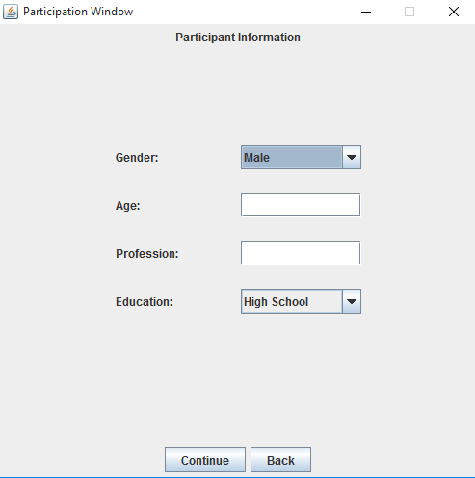

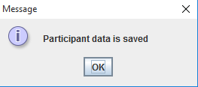

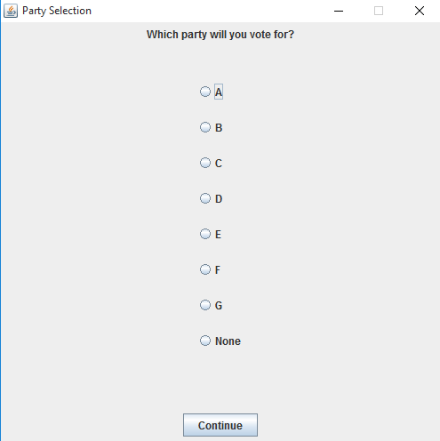

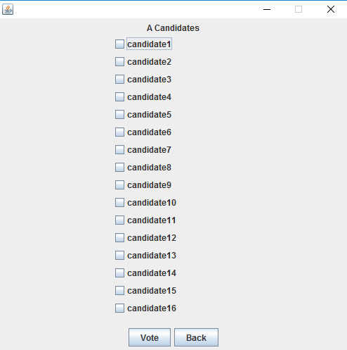

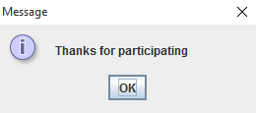

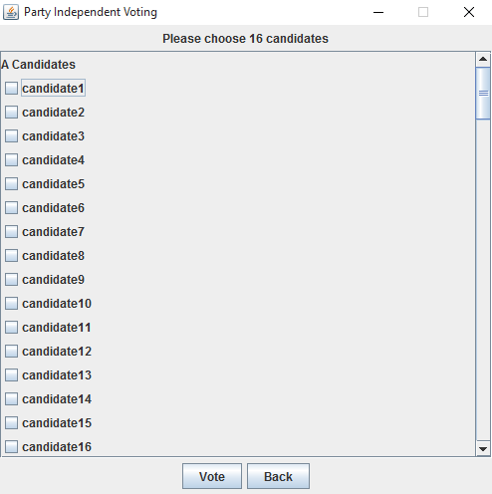

Remember that these samples are implemented using Swing. If you would like to create a web app using servlets, then you may design your web pages accordingly with the provided the samples provided.

**PART 2: Data Storage**

You can use any type of files (txt, dat or etc) or any open source databases you like. Make sure that you collect all the data from the ui to be stored in your files or databases. Demographics data about the candidate, and also the party voted, along with the candidates.

**PART 3: Documentation**

Additionally, you should provide a document including the documentation of your application. It should include diagrams, explanations and samples of the interfaces.

Expected Diagrams (Mandatory):

1 Use case diagram for the user operations

1 Class Diagram showing your design for the application

1 Activity Diagram to show the activity of a user

1 Sequence Diagram showing the messages for the specified activity.

You may add more diagrams which will increase your chance to get higher results.